DAY 15 REPORT:
Task 1 – Student Result Table and Box Plot using NumPy, Pandas, and Seaborn.
NumPy, Pandas, and Seaborn are Python libraries used for data handling and visualization. In this task, student roll numbers and marks were created using NumPy arrays. Pass or fail status was generated based on marks. The data was organized into a table using Pandas DataFrame, and a box plot was created using Seaborn to visualize the student marks clearly.
Program:
import numpy as np
import pandas as pd
import seaborn as sns
import matplotlib.pyplot as plt
roll=np.array([1,2,3,4,5,6,7,8,9,10,11,12])
marks=np.array([85,35,67,25,90,95,56,78,82,10,98,100])
status=np.where(marks>=40,"Pass","Fail")
df=pd.DataFrame({
"Roll No":roll,
"Marks":marks,
"Result":status
})
print(df)
sns.boxplot(y=df["Marks"])
plt.title("Student Marks Box Plot")
plt.show()
Output
A table containing roll number, marks, and pass/fail status was created successfully. A box plot was also generated to visualize the marks distribution.
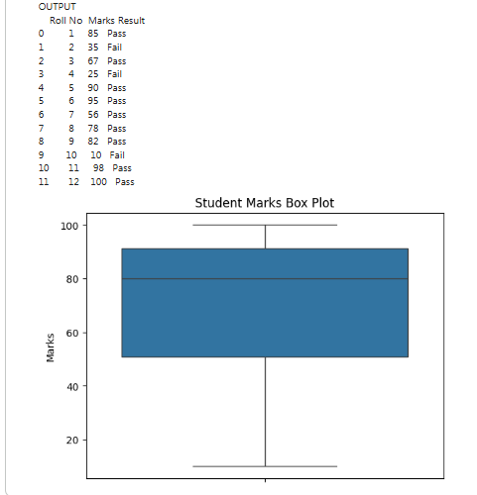
Task 2 – Count Plot for Pass and Fail Students
Introduction
In this task, student marks were analyzed to identify pass and fail students. NumPy was used to create arrays, Pandas was used to create a table, and Seaborn count plot was used to visually compare the number of passed and failed students.
Program:
import numpy as np
import pandas as pd
import seaborn as sns
import matplotlib.pyplot as plt
roll=np.array([1,2,3,4,5,6,7,8,9,10,11,12])
marks=np.array([85,35,67,25,90,95,56,78,82,10,98,100])
status=np.where(marks>=40,"Pass","Fail")
print("OUTPUT")
df=pd.DataFrame({
"Roll No":roll,
"Marks":marks,
"Result":status
})
print(df)
sns.boxplot(y=df["Marks"])

plt.title("Student Marks Box Plot")
plt.show()
sns.countplot(x=df["Result"])
plt.title("Student pass fail using count plot")
plt.show()
Output
A table containing roll number, marks, and result status was displayed. The count plot visually represented the number of pass and fail students.

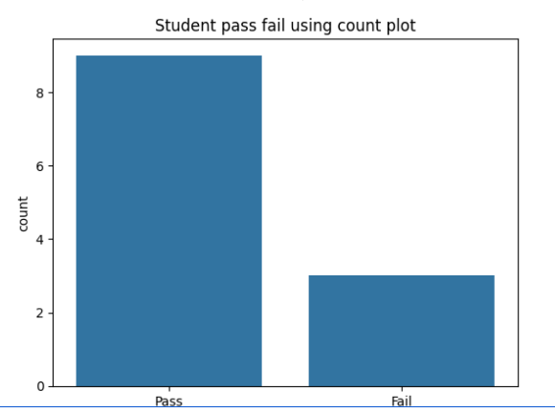
Comparison Graphs in Seaborn
Comparison graphs are used to compare values, categories, or relationships between data.
Graph | Function | Purpose
Line Graph | sns.lineplot() | Compares values over time or sequence
Bar Graph | sns.barplot() | Compares values between categories
Scatter Plot | sns.scatterplot() | Compares relationship between two variables
Box Plot | sns.boxplot() | Compares data distribution
Violin Plot | sns.violinplot() | Compares distribution and density
Count Plot | sns.countplot() | Compares count of categories
Point Plot | sns.pointplot() | Compares category values using points
Swarm Plot | sns.swarmplot() | Compares individual data points
Strip Plot | sns.stripplot() | Compares categorical scatter data

Task 3 – Scatter Plot and Line Plot using Seaborn
Introduction
In this task, student marks and result status were analyzed using Scatter Plot and Line Plot. NumPy was used to create arrays, Pandas was used to organize the data into a table, and Seaborn was used to visualize the comparison between pass and fail students.

Scatter Plot Program
import numpy as np
import pandas as pd
import seaborn as sns
import matplotlib.pyplot as plt
marks=np.array([85,35,67,25,90])
result=np.where(marks>=40,"Pass","Fail")
df=pd.DataFrame({
"Marks":marks,
"Result":result
})
sns.scatterplot(x=df["Result"], y=df["Marks"])
plt.title("Pass and Fail Scatter Plot")
plt.show()
Output
A scatter plot was generated successfully to display the relationship between student result status and marks.
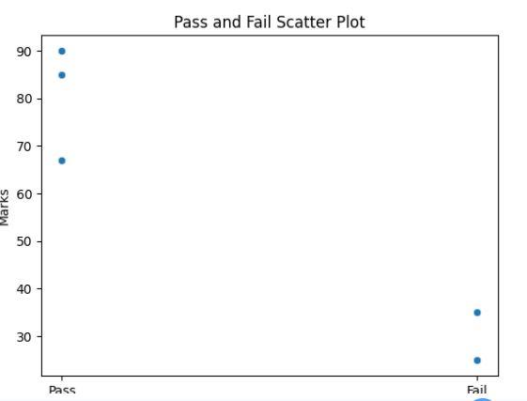

2.Line Graph
A line graph is used to represent and compare data values using connected lines. It helps to visualize changes and trends between different categories or values.

Program
import numpy as np
import pandas as pd
import seaborn as sns
import matplotlib.pyplot as plt
marks=np.array([85,35,67,25,90])
result=np.where(marks>=40,"Pass","Fail")
df=pd.DataFrame({
"Marks":marks,
"Result":result
})
sns.lineplot(x=df["Result"], y=df["Marks"])
plt.title("Pass and Fail Line Graph")
plt.show()

Output
A line graph was generated successfully to compare the marks of pass and fail students.
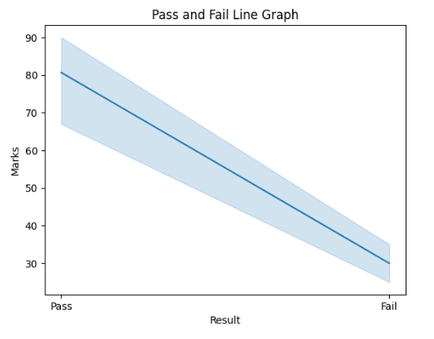
Task 4 – Graphs Creation for sample student data using Seaborn
Introduction
Seaborn is a Python visualization library used to create statistical and attractive graphs easily. In this task, an Excel student dataset was read using Pandas and different types of graphs were created using Seaborn to analyze student marks, attendance, and result status visually.

Program
import pandas as pd
import seaborn as sns
import matplotlib.pyplot as plt
# Reading Excel Dataset
df = pd.read_excel("/content/sampleStudentDataset.xlsx")
# Display Dataset
print(df)
# 1. Line Graph
sns.lineplot(x=df["Name"], y=df["Marks"])
plt.title("Student Marks Line Graph")
plt.xlabel("Student Name")
plt.ylabel("Marks")
plt.xticks(rotation=45)
plt.show()
# 2. Bar Graph
sns.barplot(x=df["Name"], y=df["Marks"])
plt.title("Student Marks Bar Graph")
plt.xlabel("Student Name")
plt.ylabel("Marks")
plt.xticks(rotation=45)
plt.show()
# 3. Scatter Plot
sns.scatterplot(x=df["Attendance"], y=df["Marks"])
plt.title("Attendance vs Marks Scatter Plot")
plt.xlabel("Attendance")
plt.ylabel("Marks")
plt.show()
# 4. Box Plot
sns.boxplot(y=df["Marks"])
plt.title("Student Marks Box Plot")
plt.show()
# 5. Count Plot
sns.countplot(x=df["Result"])
plt.title("Pass and Fail Count Plot")
plt.xlabel("Result")
plt.ylabel("Count")
plt.show()

Output
- A line graph was generated to compare student marks.
- A bar graph was created to visualize marks of students.
- A scatter plot was generated to compare attendance and marks.
- A box plot was created to visualize marks distribution.
- A count plot was generated to compare pass and fail student count.
